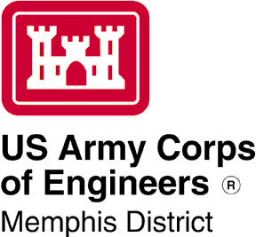
ISSUE DATE: November 7, 2022

EXPIRATION DATE: November 21, 2022

PUBLIC NOTICE

U.S. Army Corps of Engineers
Memphis District

U.S.C. Chapter 33, Section 408 Permission Evaluation

TITLE: Section 408 Permission Evaluation for Wolf River Hollywood Street Bridge Repair, Shelby County, Tennessee.

INTRODUCTION: The authority to grant permission for temporary or permanent alterations of any U.S. Army Corps of Engineers (USACE) federally authorized civil works project is contained in Section 14 of the Rivers and Harbors Act of 1899 and codified in 33 USC 408. The City of Memphis has requested a Section 408 Permission Evaluation to repair excessive erosion and scouring that is occurring around the piers of the Hollywood Street Bridge in the Wolf River (Figure 1).

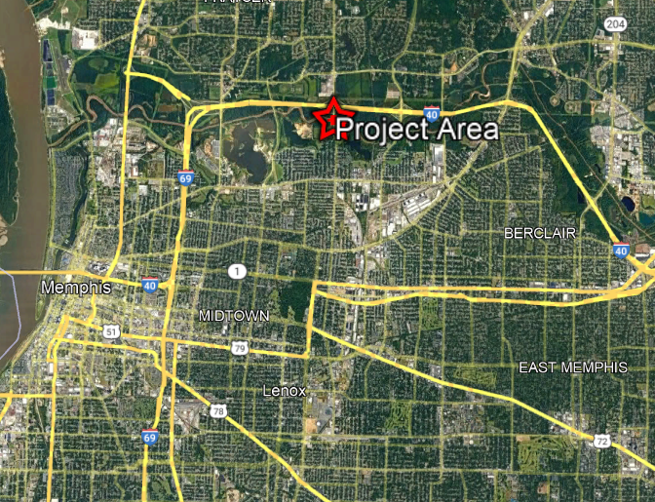
Figure 1. Project area of proposed bridge repairs, Shelby County, Tennessee.

PROJECT DESCRIPTION: Section 408 authorizes USACE to grant permission for the alteration or occupation or use of the project if USACE determines that the activity will not be injurious to the public interest and will not impair the usefulness of the project. The Mississippi River and Tributaries system, the federally authorized civil works project proposed for alteration, provides for managing flood risks to lands outside of the levees from floodwaters of the Mississippi River. The purpose of this project is to repair excessive erosion and scouring that is impairing the integrity of the Hollywood Street Bridge that crosses the Wolf River in Shelby County, Tennessee (Figure 2). The proposed project would install bank stabilization structures, including sheet piling and riprap, along approximately 140 linear feet of the north bank of the Wolf River.

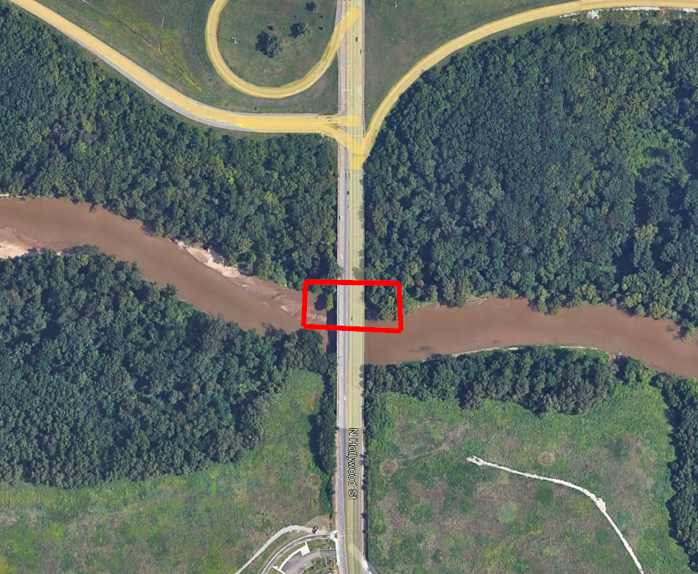
Figure 2. Hollywood Street Bridge crossing the Wolf River, Shelby County, Tennessee.

ENVIRONMENTAL COMPLIANCE: A decision on a Section 408 request is a federal action, and therefore subject to the National Environmental Policy Act (NEPA) and other environmental compliance requirements. The scope of analysis for the NEPA and environmental compliance evaluations for the Section 408 review should be limited to the area of alteration and those adjacent areas that are directly or indirectly affected by the alteration. The proposed project meets criteria set forth in Nationwide Permit 13, Bank Stabilization. Additionally, as the proposed Section 408 alteration is within the USACE project footprint, no known historic properties would be affected. Furthermore, the proposed Section 408 alteration was determined to have no effect on threatened or endangered species or their critical habitat pursuant to the
Endangered Species Act. The decision on this Section 408 request is being analyzed in accordance with NEPA and is limited to the Section 408 boundaries described herein.

PUBLIC INTEREST REVIEW: The purpose of this notice is to solicit comments from the public; federal, state, and local agencies and officials; Native American Tribes; and other interested parties. Comments received within 15 days of this publication will be used in the evaluation of potential impacts of the proposed action on important resources. All comments will be considered in preparing environmental documentation pursuant to NEPA. USACE has jurisdiction under 33 USC 408 only over the specific activities that have the potential to alter existing USACE projects.

Please limit comments to the area of the alteration and those adjacent areas that are directly or indirectly affected by the alteration to the federally authorized civil works project described herein. Comments may be submitted to jennifer.hiltonsmith@usace.army.mil and should be received by November , 2022.

Sincerely,

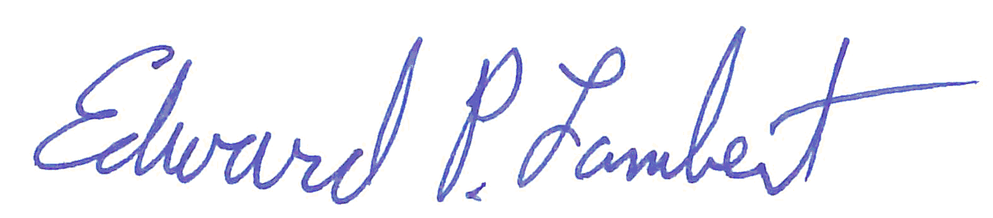

Edward P. Lambert
Chief, Environmental Compliance Branch
Regional Planning and Environmental Division South

